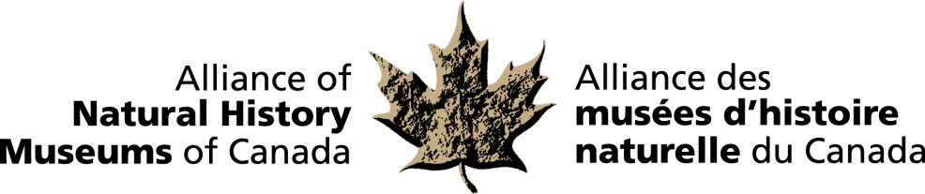

Dr. Francis Cook, Researcher Emeritus at the Canadian Museum of Nature, was honoured with the inaugural Gold Leaf Award by the Alliance of Natural History Museums of Canada (ANHMC). This new award recognizes exceptional contributions to the study of museum-based natural history in Canada.

Dr. Cook enjoyed a long-standing career in herpetology (the study of reptiles and amphibians) in Canada. For more than three decades, he curated the Museum’s national herpetology collections, overseeing a 10-fold increase in the number of specimens. And, for 31 years, was the editor of the Canadian Field-Naturalist, published by the Ottawa Field-Naturalists’ Club (OFNC), putting countless hours of work into this quarterly publication, which is Canada’s premier natural history journal.

Numerous researchers who have become well-known in Canadian natural history circles published their first paper in the Canadian Field-Naturalist…including Dr. Cook. OTTAWA –

For more information and to arrange interviews, contact:
Elizabeth McCrea
Alliance of Natural History Museums of Canada
613-410-1199

