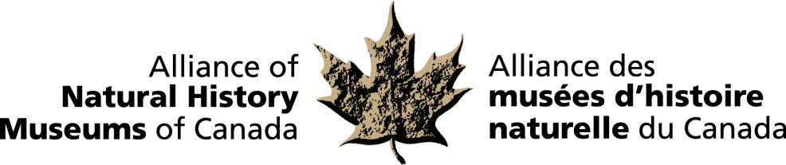

Dr. Jon C. Barlow, a respected scientist who devoted his career to the study of bird evolution received the distinguished Bruce Naylor Award. Dr. Barlow was most known in museum circles as the Curator of Ornithology at Toronto’s Royal Ontario Museum (ROM) – a position he held for 35 years until 2001. He also led the University of Toronto’s Museum Studies Program, inspiring numerous students to pursue careers in natural sciences and museum administration.

It has been said that through his unique combination of talents -- researcher, collector, curator, educator, mentor, editor, administrator and larger-than-life personality – he transformed the ornithology program into a flagship department at the ROM.

His research focused on avian vocalization, specializing in the study of vireos (small to medium-sized songbirds). In fact, Dr. James Rising, an ornithologist at the University of Toronto, states: “Jon is the world’s foremost authority on vireos.”

Over the course of his career, Barlow personally contributed over 6,000 specimens to the provincial bird collection, building it into one of the largest in the world. “The ROM I think has one the best bird skeleton collections in the world largely because of his job,” says Rising.

Drs. Rising and Barlow first met as students at the University of Kansas. Both ended up coming to Canada for research positions. Explains Rising: Until the 1960s, most ornithologists pursuing graduate studies went to universities outside of the country such as Oxford or Cornell. Barlow trained students at the graduate level in Ornithology at the University of Toronto making them competitive with any in the world.

For more information and to arrange interviews, contact:
Elizabeth McCrea
Alliance of Natural History Museums of Canada
613-410-1199

