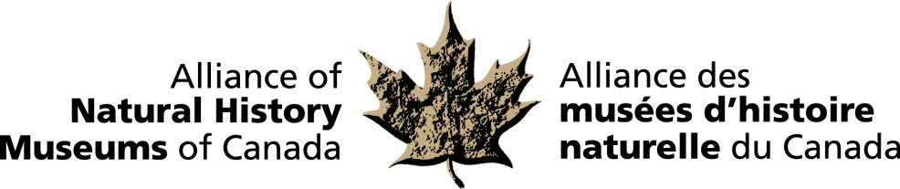

Ottawa: November 4th, 2013

Canadian Natural History Network presents Bruce Naylor Award
to Edward Burtynsky at reception on Parliament Hill

The Alliance of Natural History Museums of Canada (ANHMC) announced today that Edward Burtynsky is this year’s recipient of its Bruce Naylor Award. The announcement occurred at the organization’s annual reception on Parliament Hill, which is hosted by the Speaker of the House, the Honourable Andrew Scheer.

The award is given annually to recognize achievement by an individual or individuals of national or international significance in the natural history field in Canada through distinctive leadership, publications or other remarkable endeavours.

The ANHMC is a national network of natural history museums and similar institutions dedicated to the preservation and understanding of Canada’s natural heritage and the enhancement of the benefits museums provide to the people of Canada. This year the organization is celebrating its tenth anniversary.

“The Alliance meets annually in Ottawa to discuss collaborative projects in the areas of research, collections development and public education”, says Dr. Harold Bryant, President of the ANHMC. “Natural history museums are guardians of invaluable heritage collections which are the record of the natural environment through time. Mr. Burtynsky’s achievements of national and international significance have contributed greatly to the popularization of important environmental issues and have been a great support to the museum community in informing Canadians of the natural world.”

“I am honoured to have been chosen as the recipient for this year’s Bruce Naylor Award”, says Edward Burtynsky. “I have had the opportunity of exhibiting my work in several museums across Canada and they have provided the perfect backdrop to communicate my theme of “nature transformed through industry”. Our dependence on nature to provide materials for our consumption and our concern for the health of our planet sets us into an uneasy contradiction and hopefully my images will continue to inform the public and provide a better understanding of the world we live in.”

-30-

For more information and to arrange interviews, contact:
Elizabeth McCrea, Administrator
Alliance of Natural History Museums of Canada
613-410-1199

