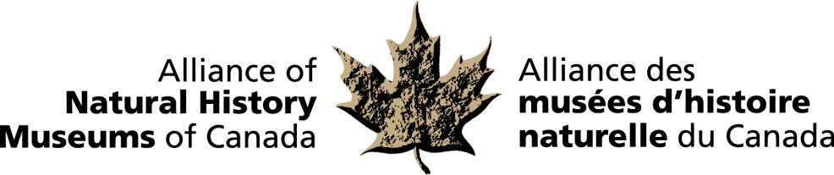

Ottawa: October 27th, 2014

Bruce Naylor Award to be presented to Joanne DiCosimo, former CEO
of the Canadian Museum of Nature, at reception on Parliament Hill.

Joanne DiCosimo is this year’s recipient of the Alliance of Natural History Museums of Canada’s
Bruce Naylor Award. The official announcement and presentation will occur this evening at the organization’s annual reception on Parliament Hill, which is hosted by the Speaker of the House, the Honourable Andrew Scheer.

The award is given annually to recognize achievement by an individual or individuals of national or international significance in the natural history field in Canada through distinctive leadership, publications or other remarkable endeavours.

The ANHMC is a national network of natural history museums and similar institutions dedicated to the preservation and understanding of Canada’s natural heritage and the enhancement of the benefits museums provide to the people of Canada.

“The Alliance meets annually in Ottawa to discuss collaborative projects in the areas of research, collections development and public education”, says Dr. Harold Bryant, President of the ANHMC. “Natural history museums are guardians of invaluable heritage collections which are the record of the natural environment through time. Joanne’s vision for a new national service as the CEO and President of the Canadian Museum of Nature helped inspire this network of natural history Museums of Canada that we are so very proud of today. ”

“What distinguishes Joanne DiCosimo as an exceptional museum practitioner is the breadth of her vision for museums”, says Robert R. Janes, Editor-in-Chief, Museum Management and Curatorship. “Her entire career demonstrates an open-minded willingness to share, collaborate and forge solutions to complex challenges. Most importantly, her work is grounded in a well-developed sense of social responsibility.”

“I am honoured and humbled to have been chosen as the recipient for this year’s Bruce Naylor Award”, says Joanne DiCosimo. “As one of the original founders of this network in 2003, I am thrilled to see that, after eleven years, this group, comprised of equal and independent museums partners, continues to pursue the mutual goal of connecting people with nature. Since its inception in 2003, the network gave us a base from which we can launch important national initiatives in natural history and science and it continues to enable collaboration from coast to coast to coast.”

-30-

For more information and to arrange interviews, contact:
Elizabeth McCrea
Alliance of Natural History Museums of Canada
613-410-1199

