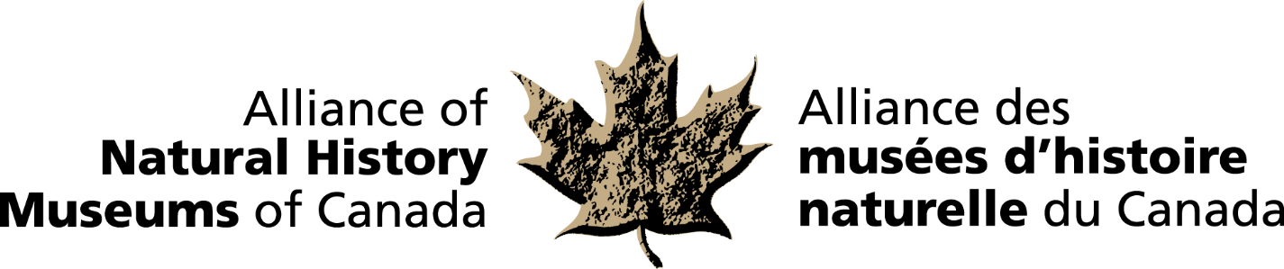
MEDIA RELEASE
RELEASE DATE: October 16, 2017

CANADIAN MUSEUM OF NATURE RESEARCHER EMERITUS
RECIPIENT OF THE 2017 BRUCE NAYLOR AWARD

Dr. Irwin Brodo is the 2017 recipient of the Alliance of Natural History Museum’s (ANHMC)
Bruce Naylor Award. The award is given annually to an individual or individuals to recognize achievement of national or international significance in the field of natural history in Canada
. The award will be presented to Dr. Brodo at the annual ANHMC reception hosted by the New Brunswick Museum on October 16th in Saint John, New Brunswick. Well known in Canada and internationally, Dr. Brodo has served at the Canadian Museum of Nature as staff and Honorary Research Associate for over 50 years.

Nominated by his peers, Dr. Brodo has devoted his over 50-year career to advancing the understanding of lichens and has published over 100 peer-reviewed papers.. His book on “Lichens of North America” was the winner of the George Lawson Medal for outstanding contribution to Canadian botany. He is also responsible for growing the national lichen collection at the Canadian Museum of Nature from 18,000 to 124,000 specimens. Dr. Brodo has been a tireless and passionate advocate on the topic and has, over the years conducted many courses and workshops on the identification of lichens and popularized lichenology through guidebooks and general articles and lectures. He has also contributed greatly through his supervision of students, working with museum guests and colleagues throughout Canada and abroad. Dr. Brodo served as the President of the Canadian Parks and Wilderness Society, American Bryological and Lichenological Society, Canadian Botanical Association, Ottawa Field-Naturalists and the International Association for Lichenology.

The ANHMC is a national network of natural history museums and similar institutions dedicated to the preservation and understanding of Canada’s natural heritage and the enhancement of the benefits museums provide to the people of Canada.

For more information and to arrange interviews, contact:
Elizabeth McCrea
Chief Administrative Officer
Alliance of Natural History Museums of Canada
(613) 410-1199 / mccrealiz@gmail.com

-30-

