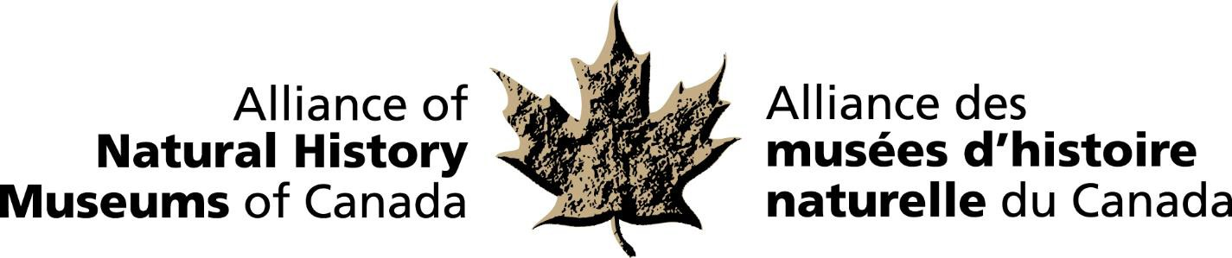

**MEDIA RELEASE**

**RELEASE DATE: October 19, 2020**

**Dr. Geoffrey G.E. Scudder**

**RECIPIENT OF THE 2020 BRUCE NAYLOR AWARD**

Dr. Geoffrey G.E. Scudder is the 2020 recipient of the Alliance of Natural History Museum’s (ANHMC) ***Bruce Naylor Award***. The award is given annually to an individual or individuals to recognize achievement of national or international significance in the field of natural history in Canada. The award will be presented to Dr. Scudder at the annual ANHMC Fall meeting hosted virtually by the Yukon Beringia Interpretive Centre, Whitehorse, Yukon on October 19th.

Dr. Scudder, zoologist, conservationist, educator and influential scientist has a long and distinguished record of service in science and has been a source of inspiration to many. He is a renowned entomologist and served as Professor and Head of the Zoology Department, and Director of the Spencer Entomological Museum, now in the Beaty Biodiversity Museum at the University of British Columbia. A champion of natural history collections and research based on them, he also continues to contribute significantly to the development of a sound strategy on biodiversity science and nature conservation in Canada.

“Dr. Scudder has led by example,” states Dr. Alwynne Beaudoin, President of the ANHMC and Director of Natural History at the Royal Alberta Museum. “His love of nature, hard work, scholarship, energy, commitment, and accomplishments have profoundly affected, both nationally and internationally, all the diverse aspects of science that he has championed.”

The ANHMC is a national network of natural history museums and similar institutions dedicated to the preservation and understanding of Canada’s natural heritage and the enhancement of the benefits museums provide to the people of Canada.

For more information and to arrange interviews, contact: Elizabeth McCrea

Chief Administrative Officer

Alliance of Natural History Museums of Canada (613) 410-1199 / [mccrealiz@gmail.com](http://?)

-30-